**Ridge Regression**

**TOTAL POINTS 2**

1.

Question 1

consider the three polynomial regression models, select the model that would most benefit from Ridge Regression:

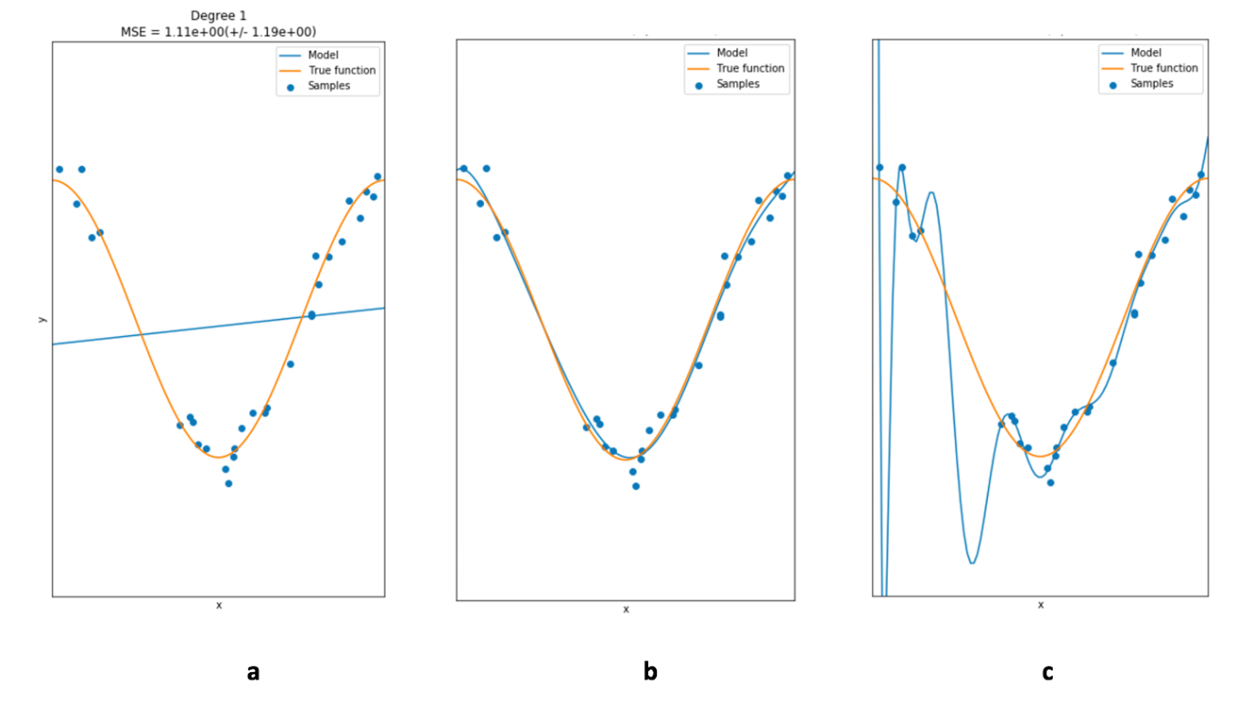

1 point



a



b



c

2.

Question 2

the following models were all trained on the same data, select the model with the highest value for alpha:

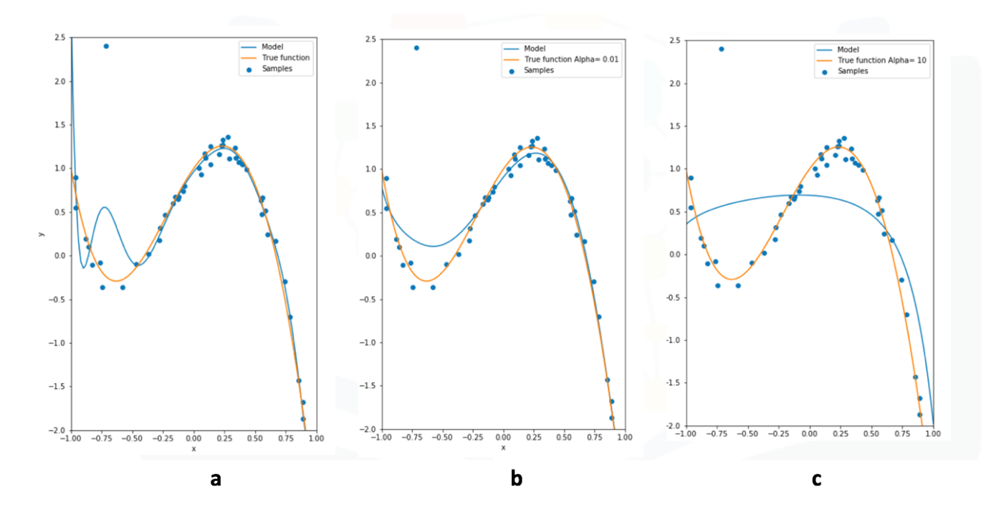

1 point



a



b



c